Travel Claim Form
Name: Paul Nathan
Email: paul@itsmart.my
Date | Time Absent |  | Jouneys |  | Purpose of Journey | Car km
 | Depart | Return | From | To
02/05/2023 | 2.52 PM | 4.21 PM | Office | SIDC | Collect SIDC Agreement | 17.2 km
 | 4.21 PM | 4.52 PM | SIDC | Office |  | 18.2 km

Claims Calculation
Total car kms | km
Claim Amount/km | RM 0.60/km
Total travel claims (Total car km * Claim Amount/km) | RM 21.24

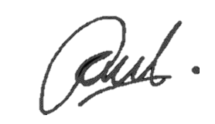
Claim requested by,

_____________________________
Name: Paul Nathan
Date: 02/05/2023

